PANTALLAZOS DE LA EVIDENCIA DE "PASS" POR PARTE DE HACKERRANK DE CADA EJERCICIO.

Arithmetic Operators

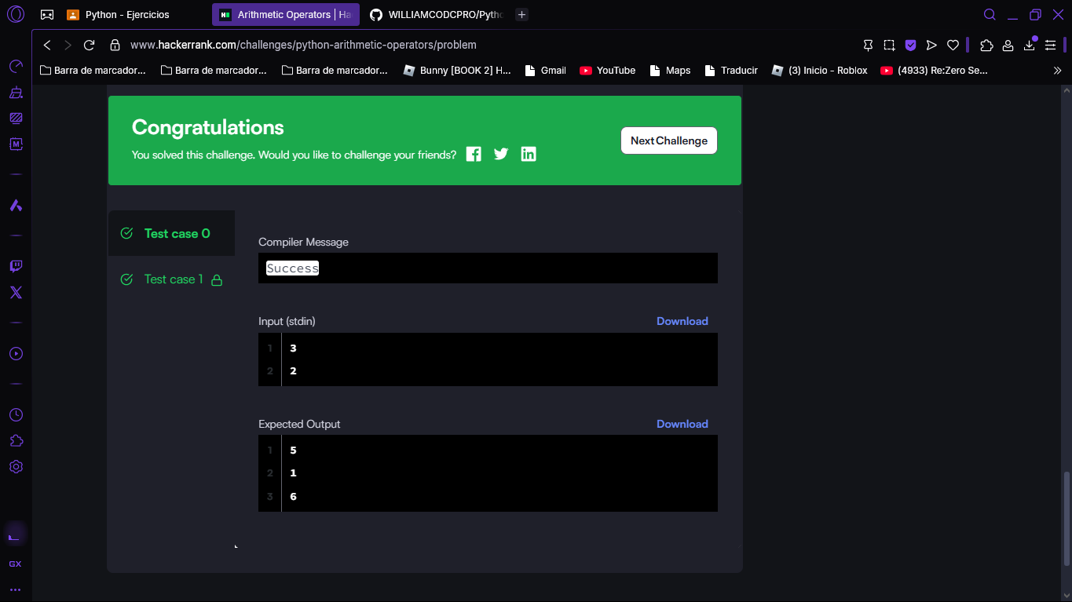

Python: Division

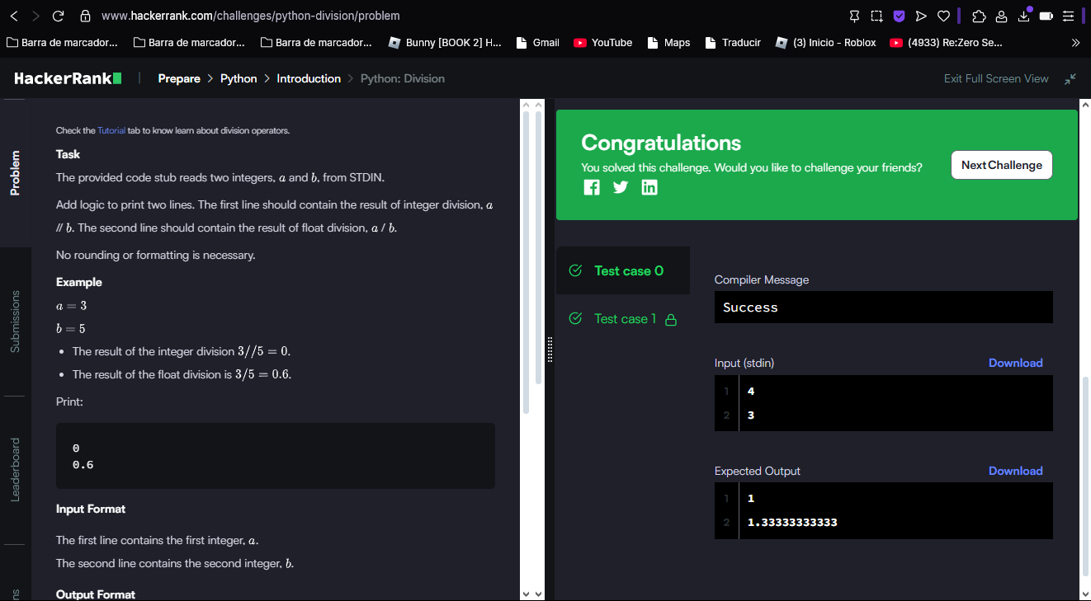

Loops

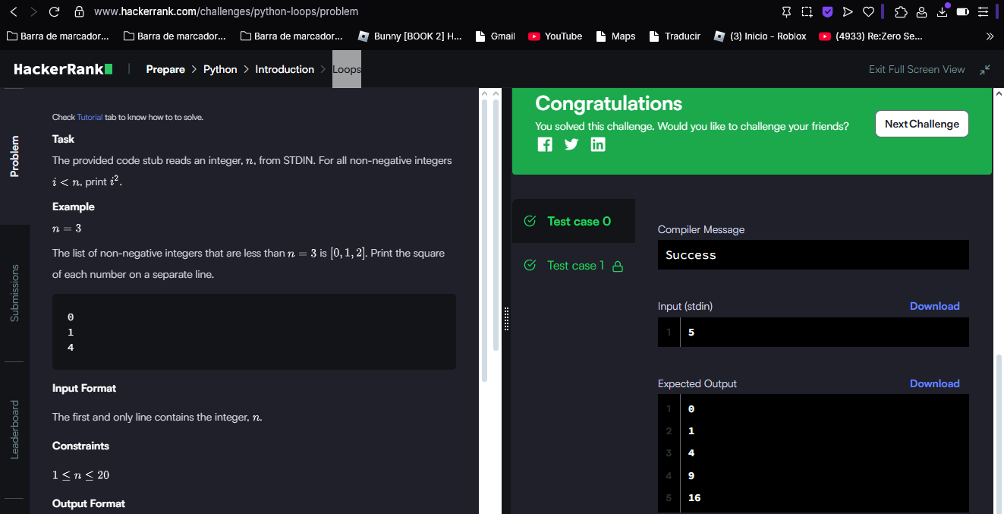

Print Function

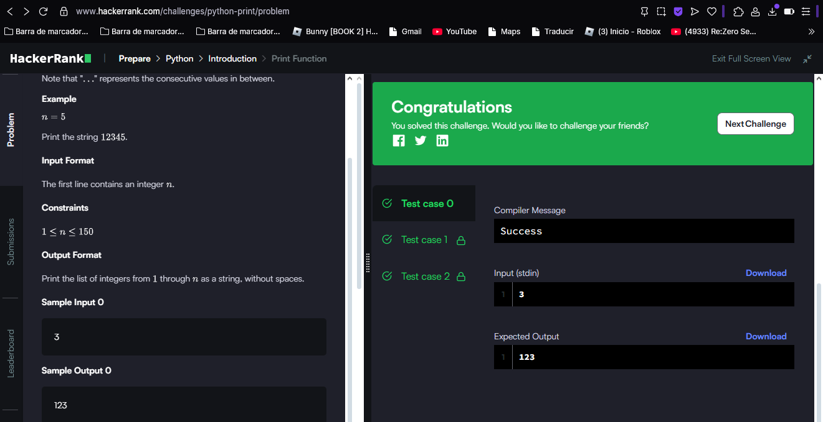

List Comprehensions

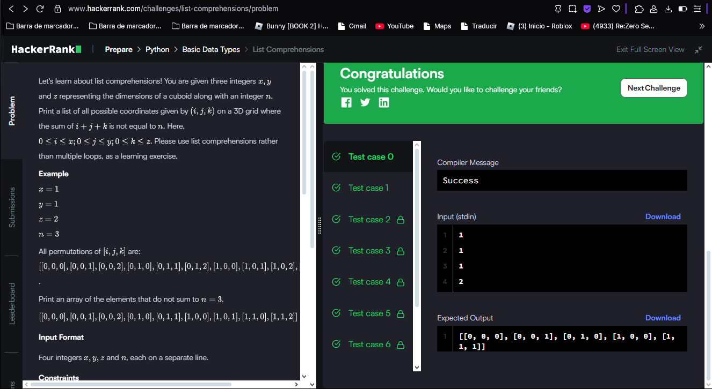

Find the Runner-Up Score!

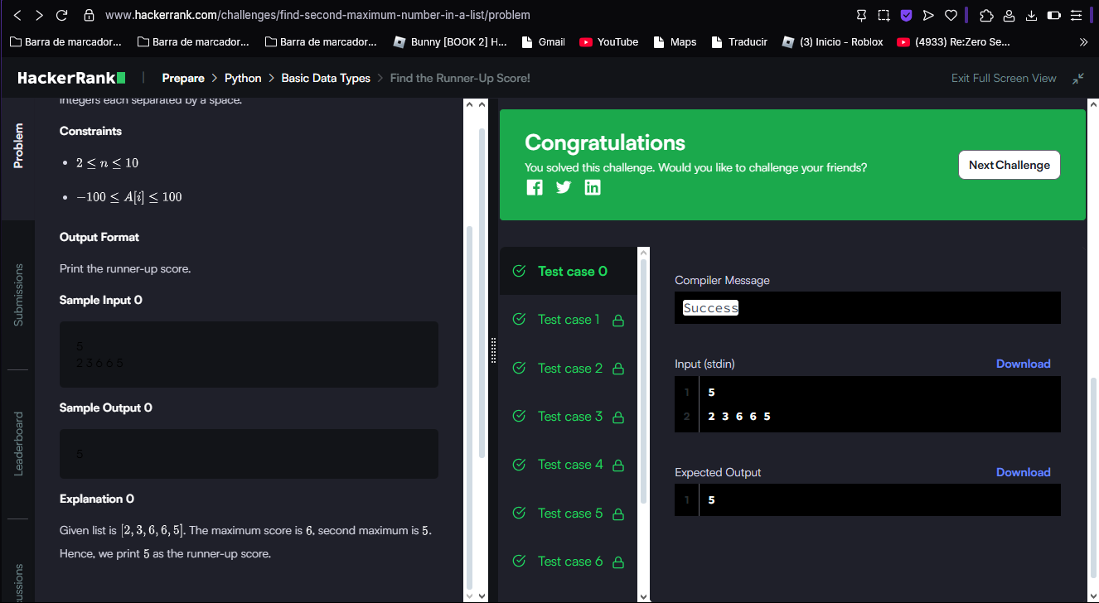

What's Your Name?

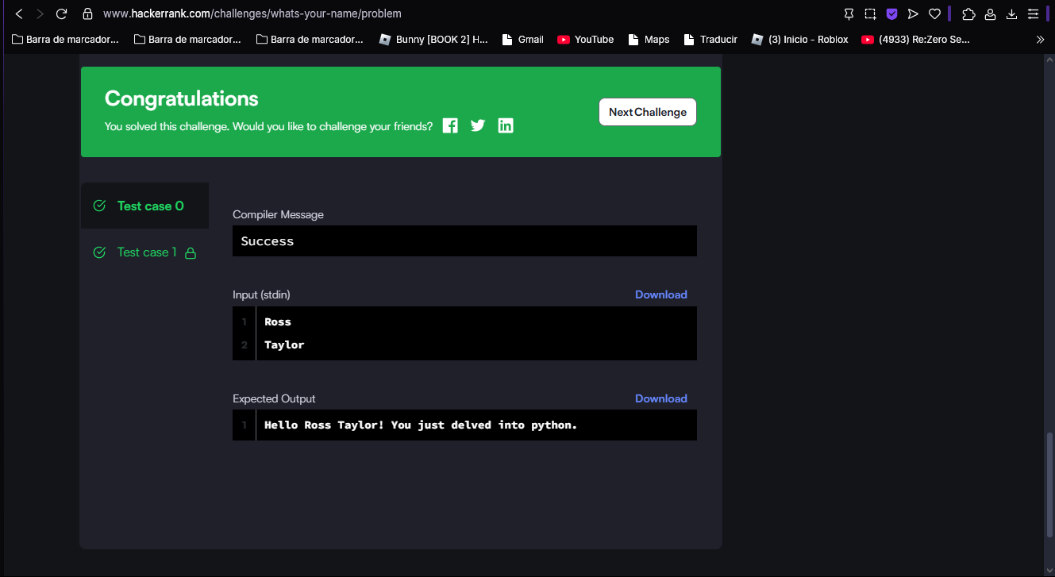

Nested Lists

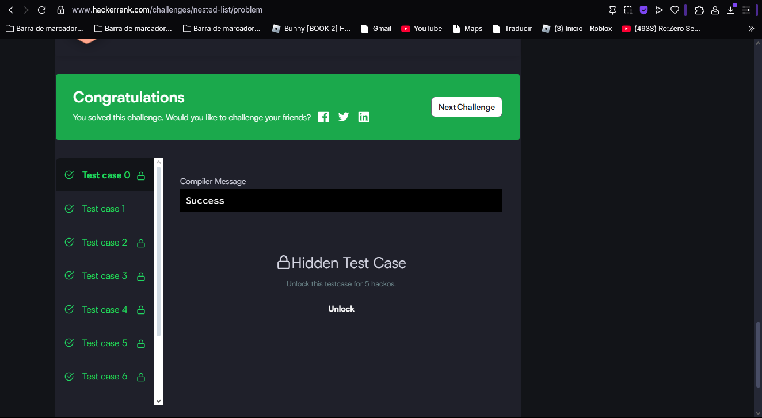

Finding the percentage